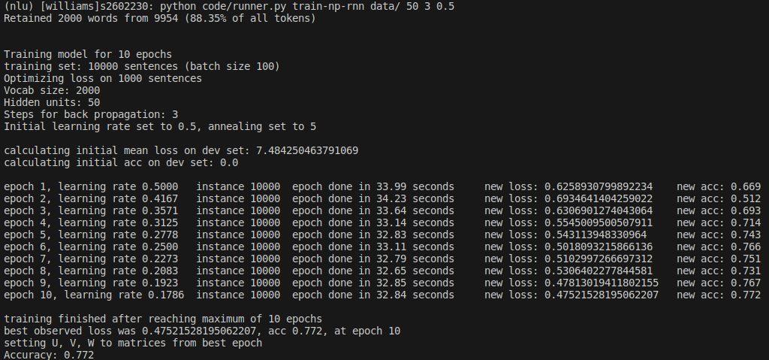
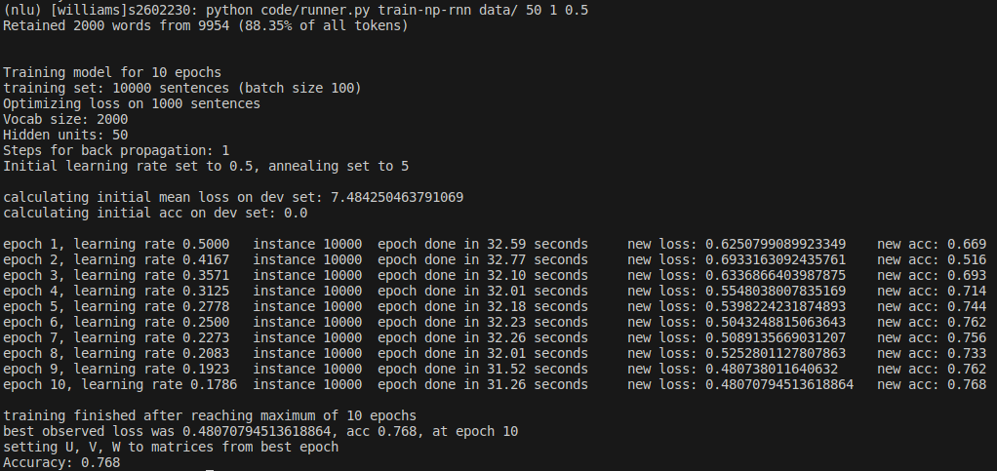

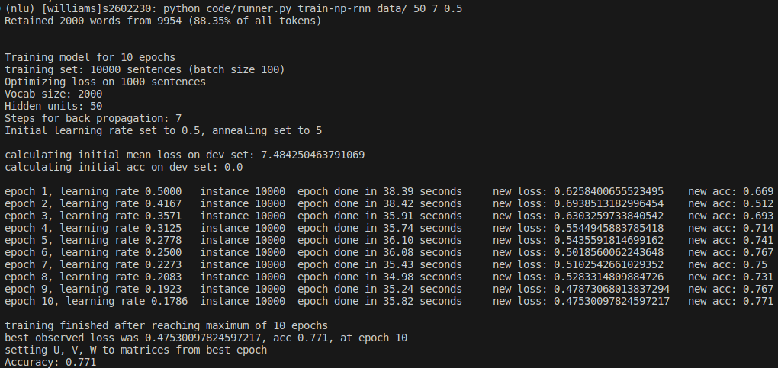

RNN

Steps | Loss | Accuracy
1 | 0.48071 | 76.8%
3 | 0.47522 | 77.2%
5 | 0.47538 | 77.2%
7 | 0.47530 | 77.1%
9 | 0.47525 | 77.1%

GRU

Steps | Loss | Accuracy
1 | 0.57631 | 79.3%
3 | 0.5657 | 79.4%
5 | 0.56173 | 79.6%
7 | 0.55854 | 79.4%
9 | 0.55928 | 79.6%
